**Week 1**

**What is AI?**

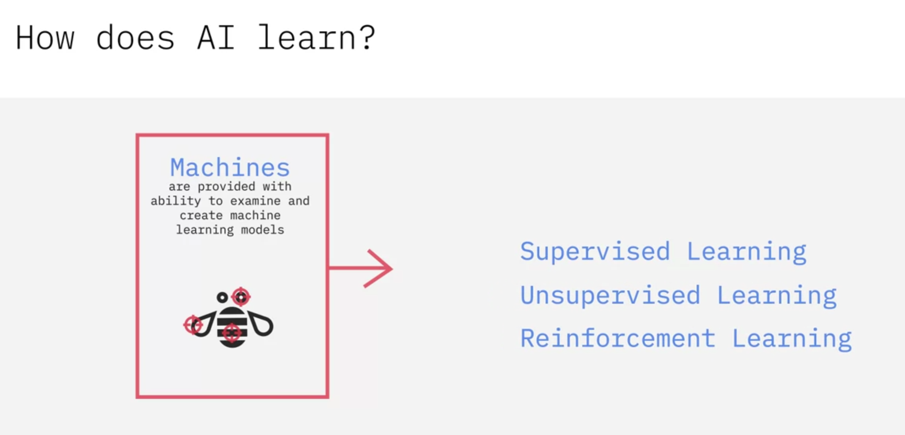

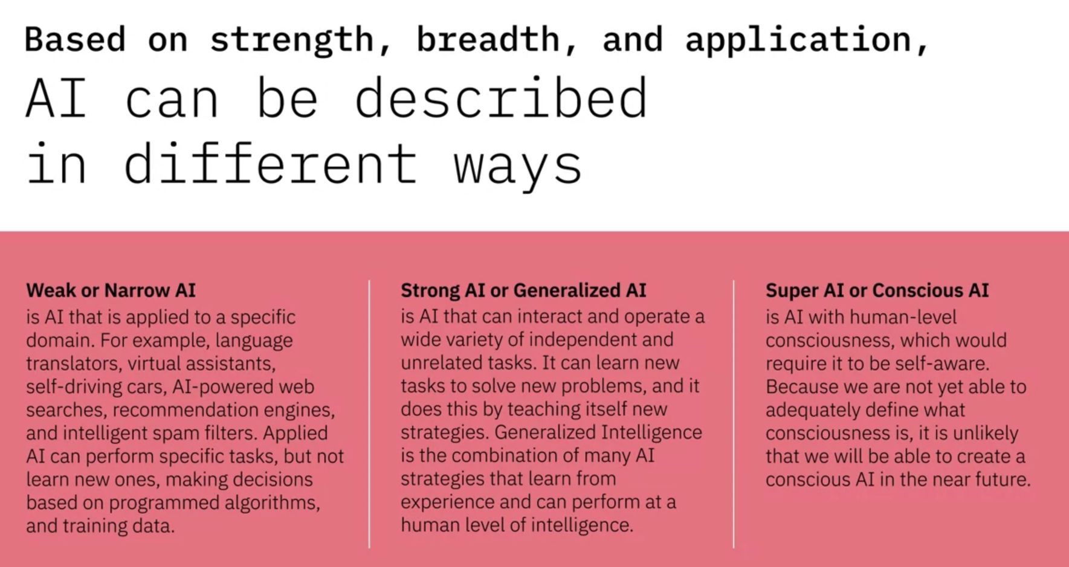

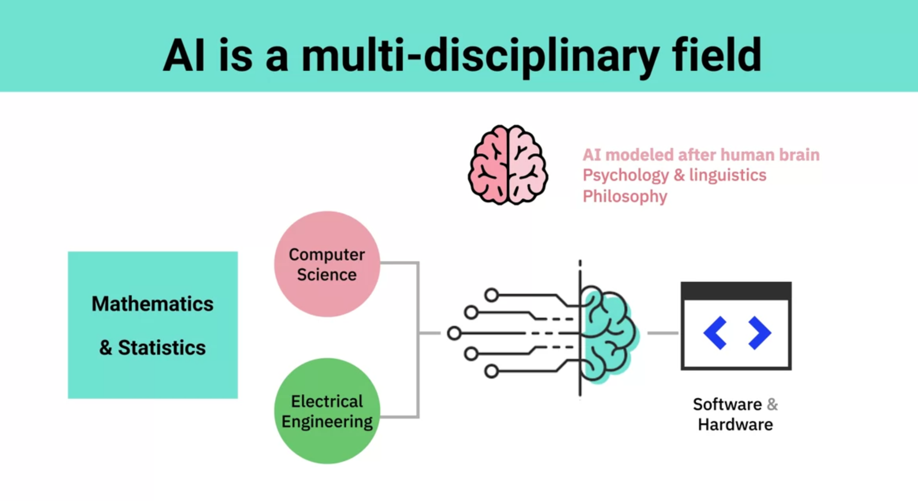

### In this lesson, you have learned:

* IBM Research defines Artificial Intelligence (AI) as Augmented Intelligence, helping experts scale their capabilities as machines do the time-consuming work.
* AI learns by creating machine learning models based on provided inputs and desired outputs.
* AI can be described in different ways based on strength, breadth, and application - Weak or Narrow AI, Strong or Generalized AI, Super or Conscious AI.
* AI is the fusion of many fields of study, such as Computer Science, Electrical Engineering, Mathematics, Statistics, Psychology, Linguistics, and Philosophy.

### To learn more about AI, read these posts:

* [AI is Not Magic: It’s Time to Demystify and Apply](https://www.ibm.com/blogs/think/2019/03/ai-is-not-magic/)
* [Women Leaders in AI](https://www.ibm.com/watson/women-leaders-in-ai/)

**Impact of AI: Applications and Examples**

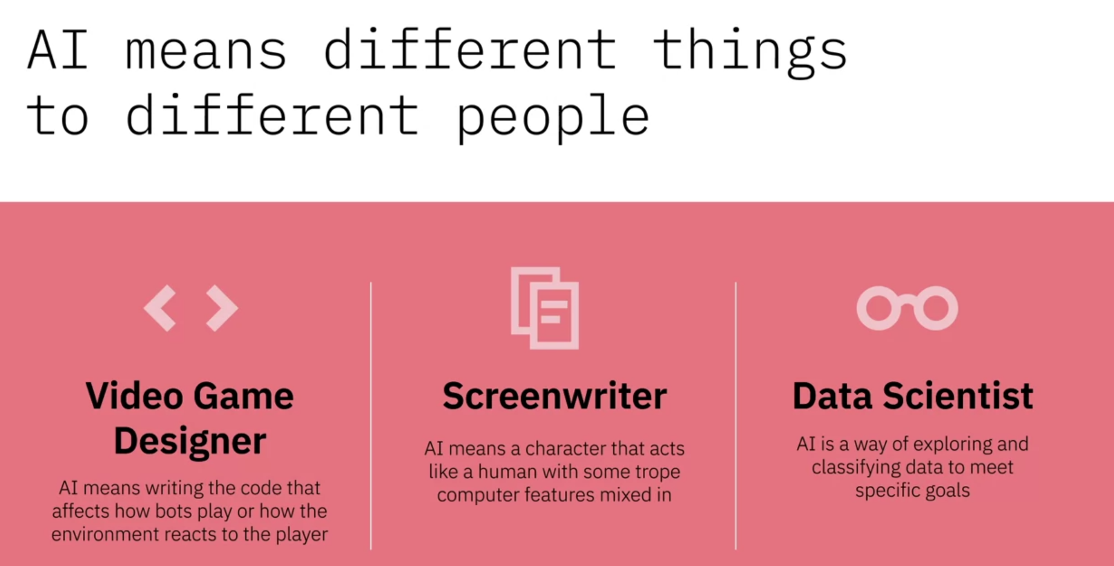

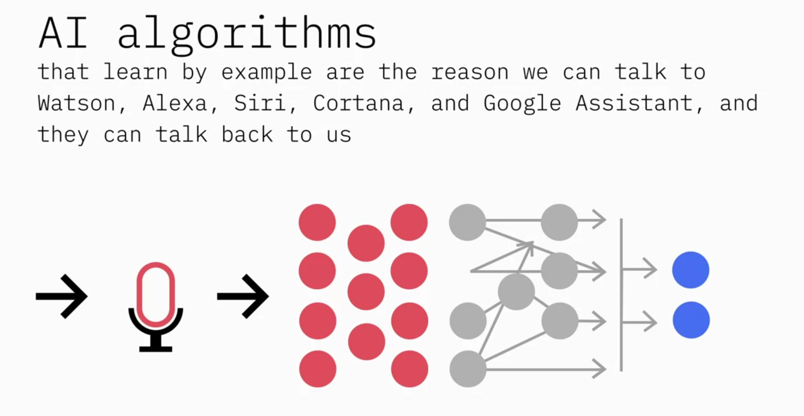

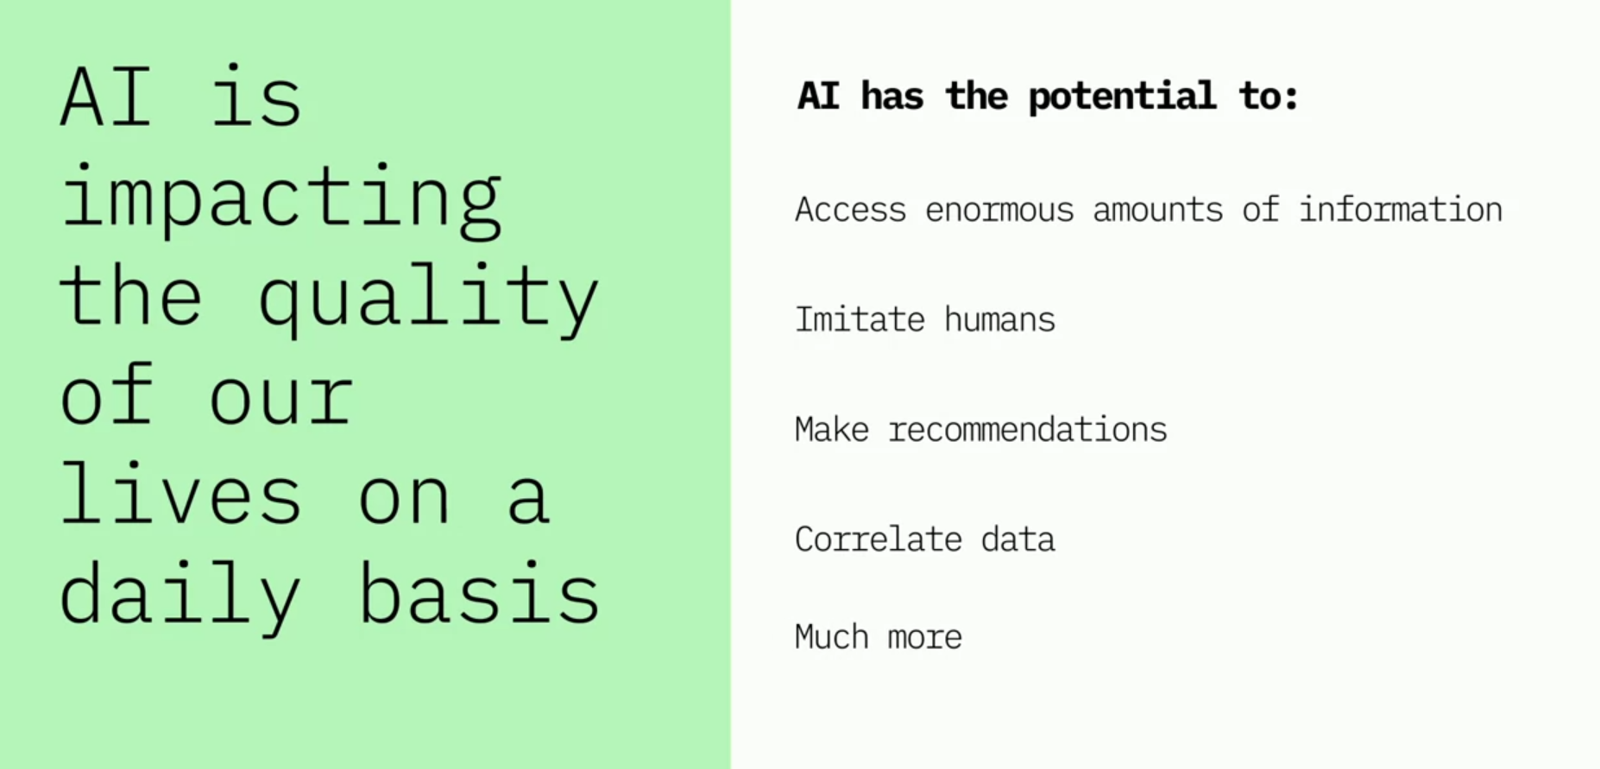

### In this lesson, you have learned:

AI-powered applications are creating an impact in diverse areas such as Healthcare, Education, Transcription, Law Enforcement, Customer Service, Mobile and Social Media Apps, Financial Fraud Prevention, Patient Diagnoses, Clinical Trials, and more.

Some of these applications include:

* Robotics and Automation, where AI is making it possible for robots to perceive unpredictable environments around them in order to decide on the next steps.
* Airport Security, where AI is making it possible for X-ray scanners to flag images that may look suspicious.
* Oil and Gas, where AI is helping companies analyze and classify thousands of rock samples to help identify the best locations to drill for oil?

Some famous applications of AI from IBM include:

* Watson playing Jeopardy to win against two of its greatest champions, Ken Jennings and Brad Rutter.
* Watson teaming up with the Academy to deliver an amplified Grammy experience for millions of fans.
* Watson collaborating with ESPN to serve 10 million users of the ESPN Fantasy App sharing insights that help them make better decisions to win their weekly matchups.

### To learn more about the applications of AI from IBM:

* [Expert Insights: AI fast forwards video for sports highlights](https://www.ibm.com/downloads/cas/XKEPLEJD)
* [IBM Watson creates the first movie trailer for 20th Century Fox](https://www.ibm.com/blogs/bluemix/2016/08/ibm-watson-creates-first-movie-trailer/)
* [USTA uses IBM Watson to enhance player performance](https://www.youtube.com/watch?v=CRJm-L-vytU)

**Week 2**

**AI Introduction**

### In this lesson, you have learned:

Cognitive computing systems differ from conventional computing systems in that they can:

* Read and interpret unstructured data, understanding not just the meaning of words but also the intent and context in which they are used.
* Reason about problems in a way that humans reason and make decisions.
* Learn over time from their interactions with humans and keep getting smarter.

### To learn more about how to get started with cognitive computing, read this post:

* [How to get started with cognitive technology](https://www.ibm.com/watson/advantage-reports/getting-started-cognitive-technology.html)

**Machine Learning, Deep Learning, Neural Networks**

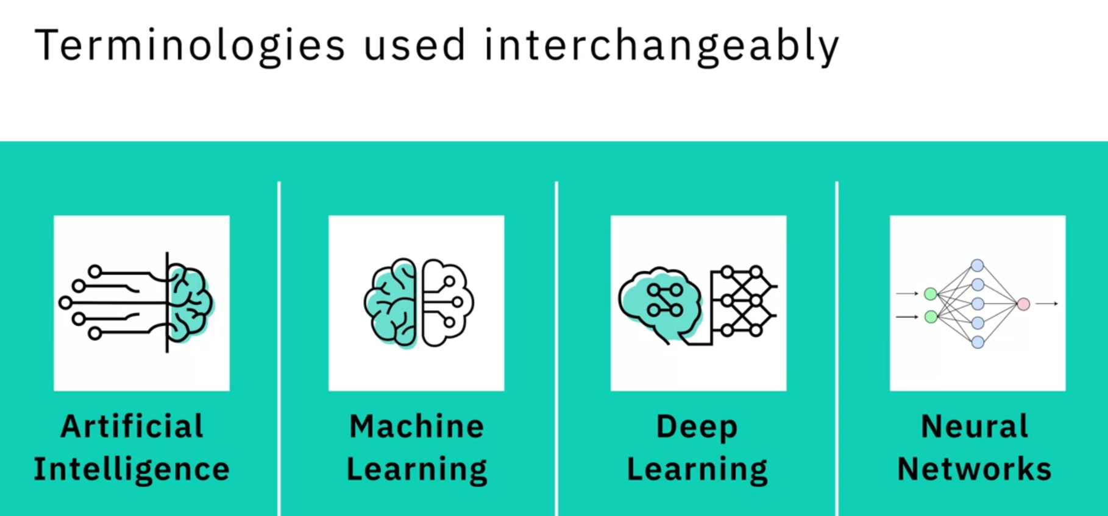

But are not the same thing.

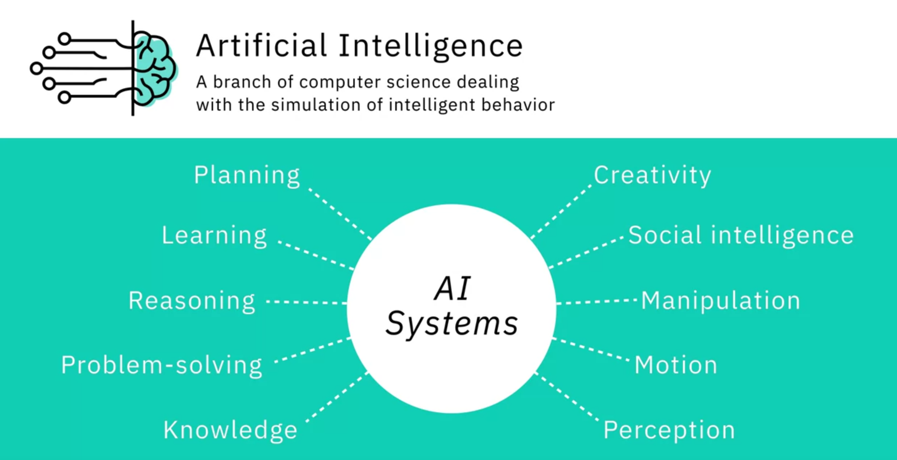

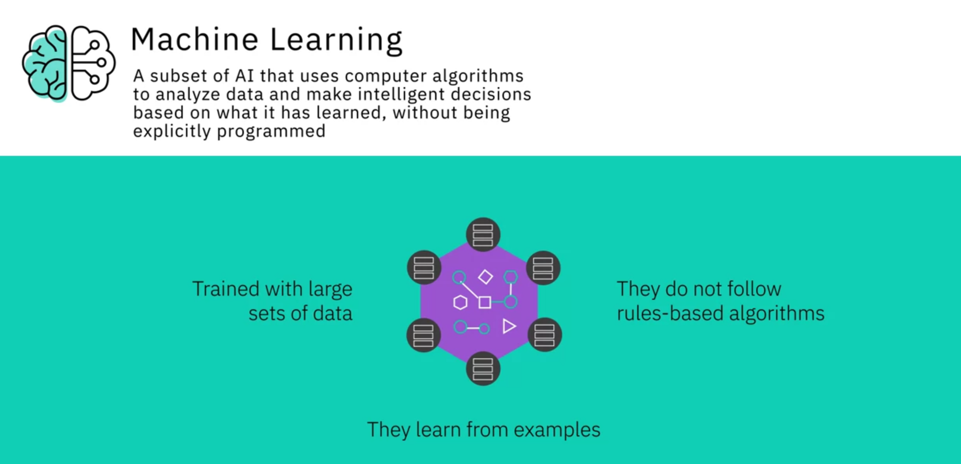

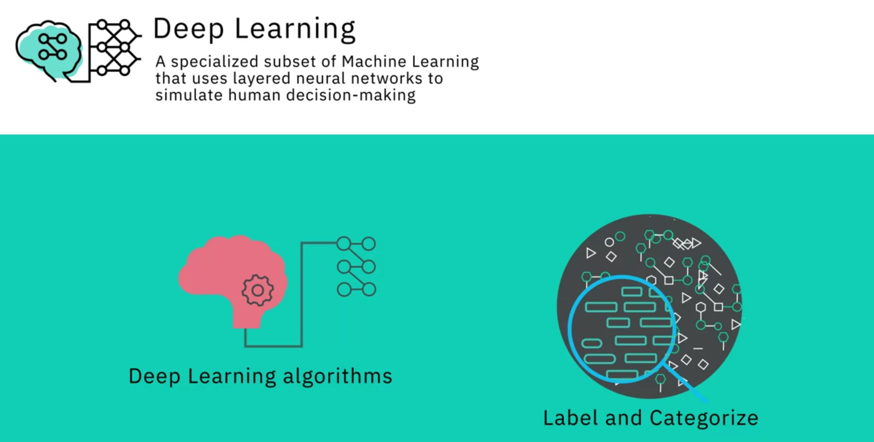

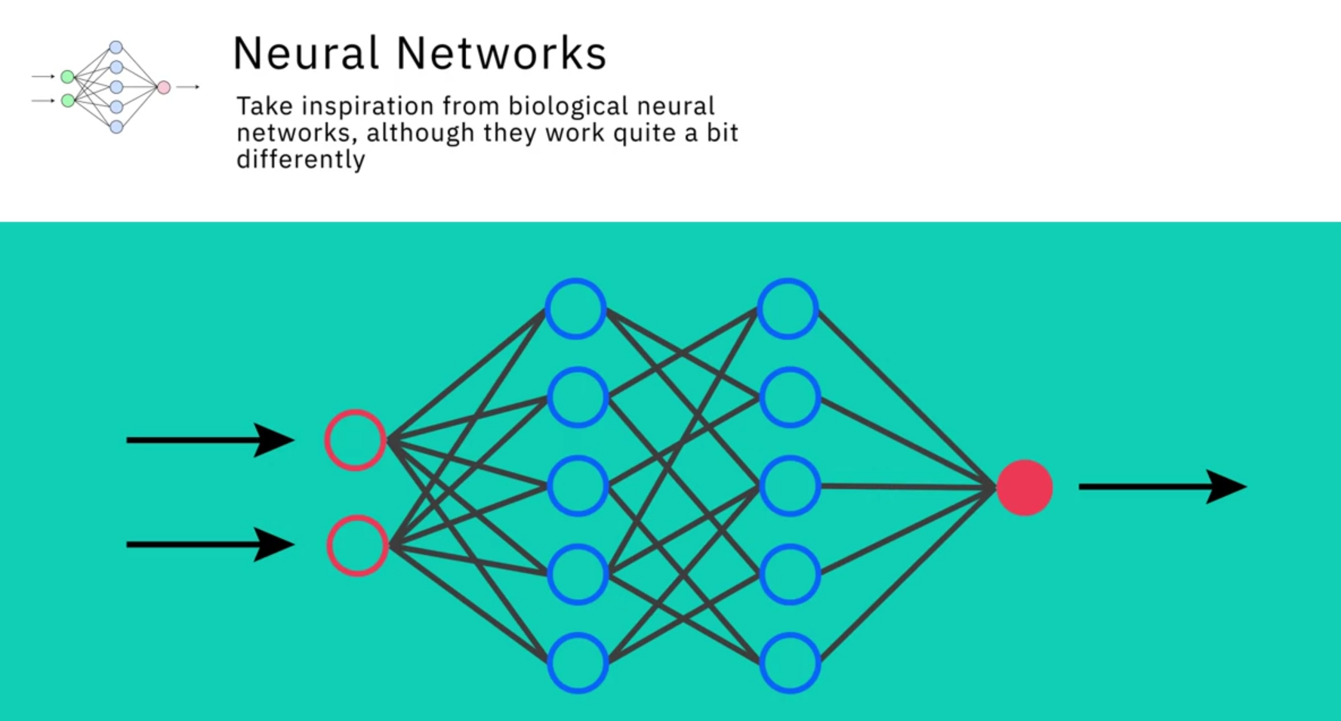

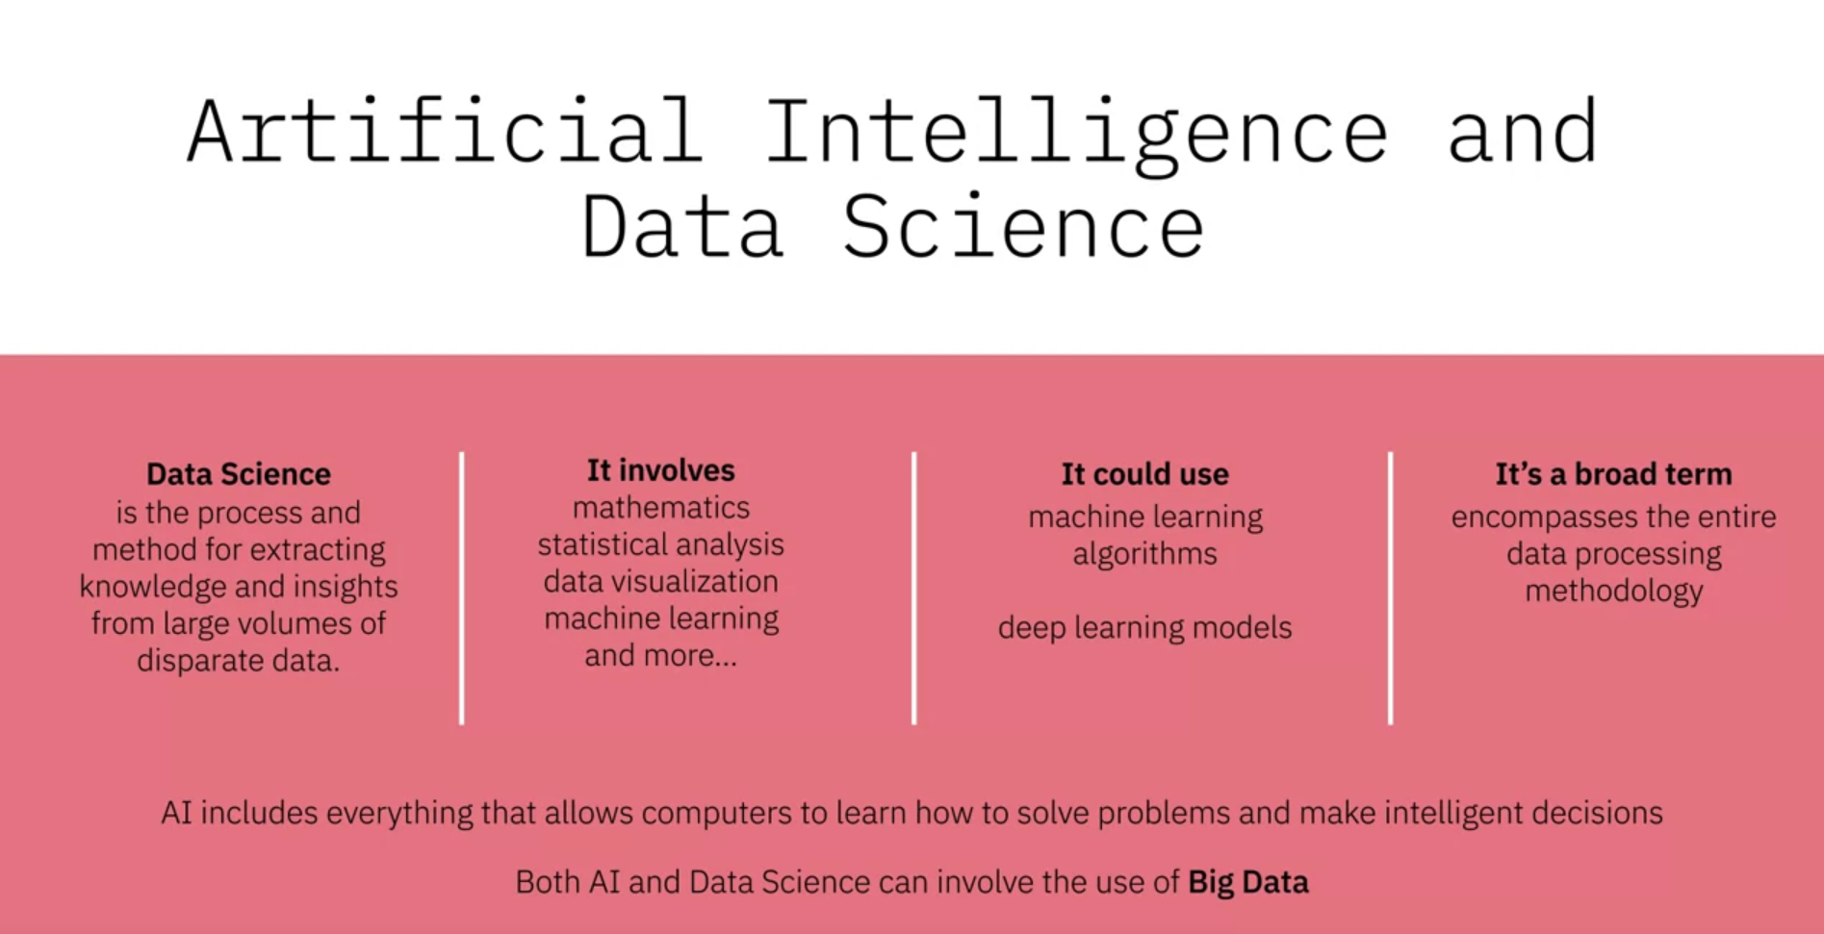

Data Science is an interdisciplinary field encompassing the entire data processing methodology. While it uses AI techniques to derive insight from data, it is NOT a subset of AI.

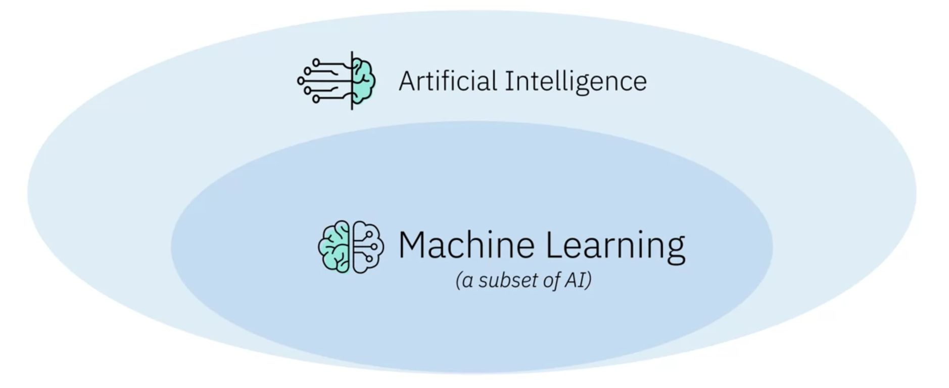

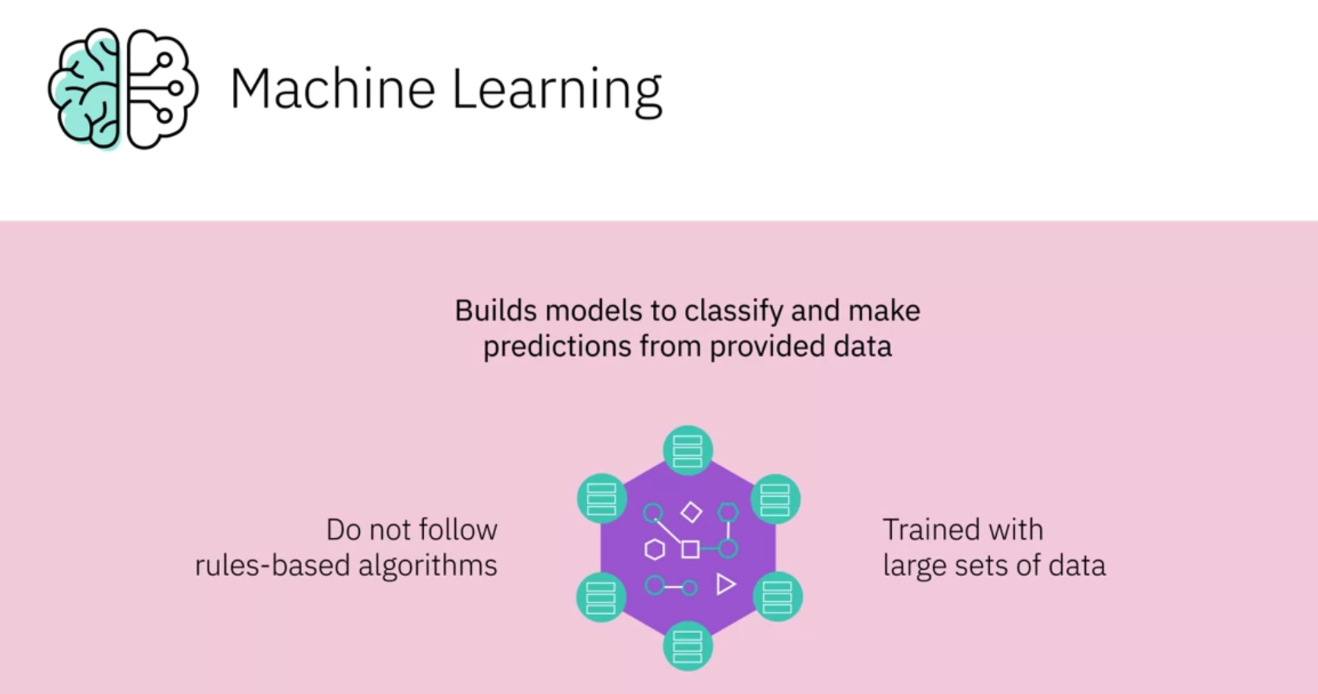

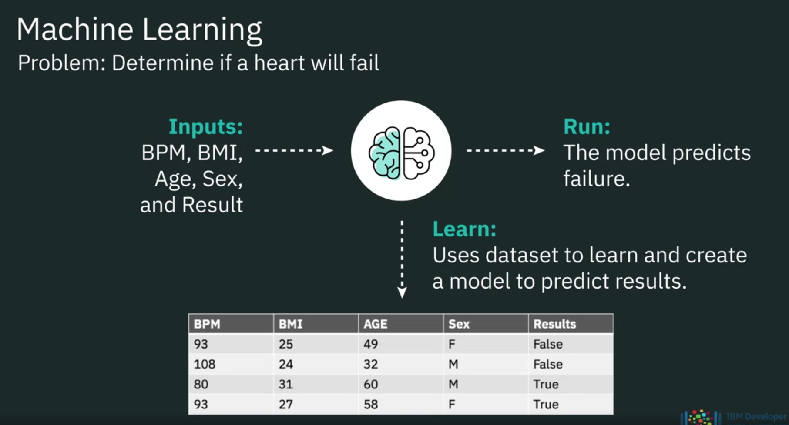

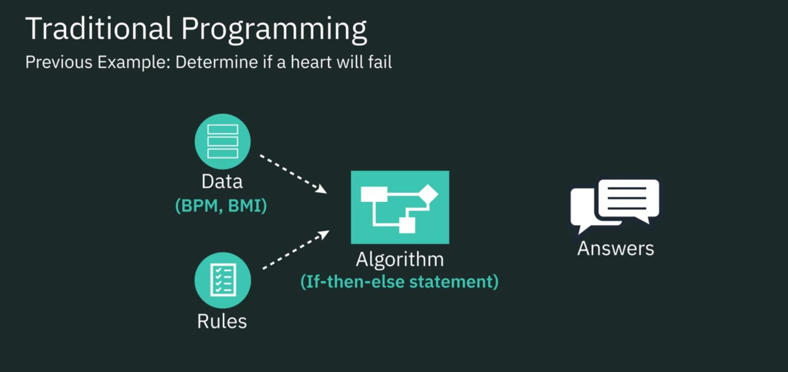

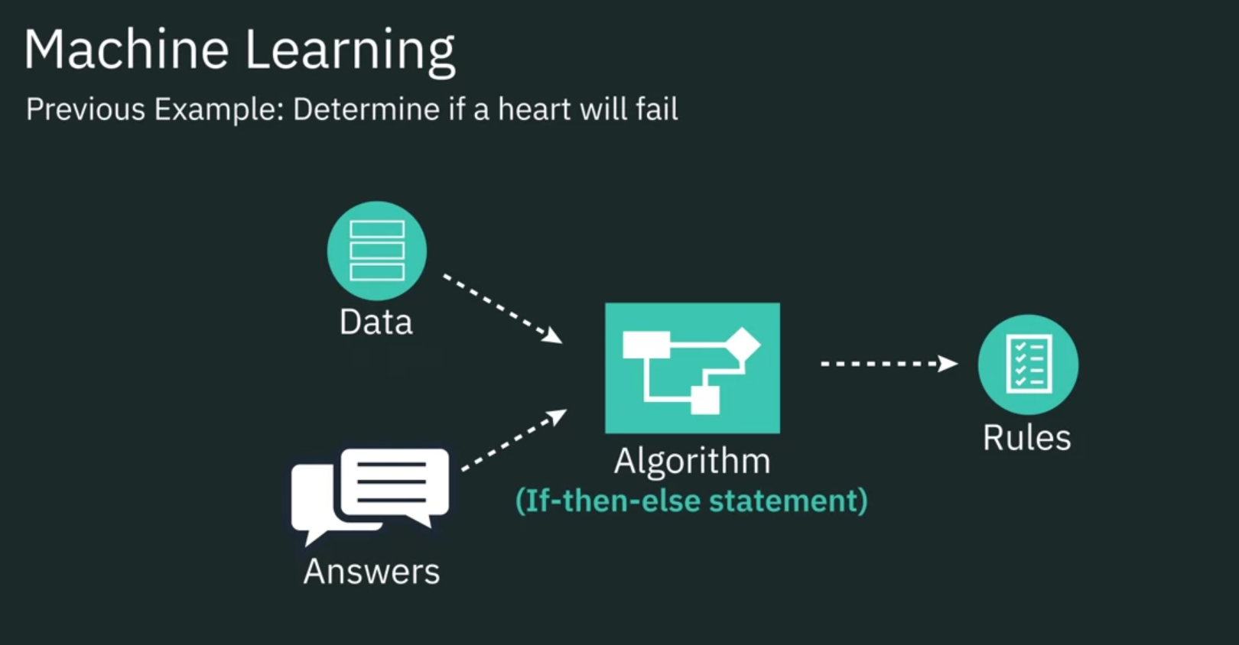

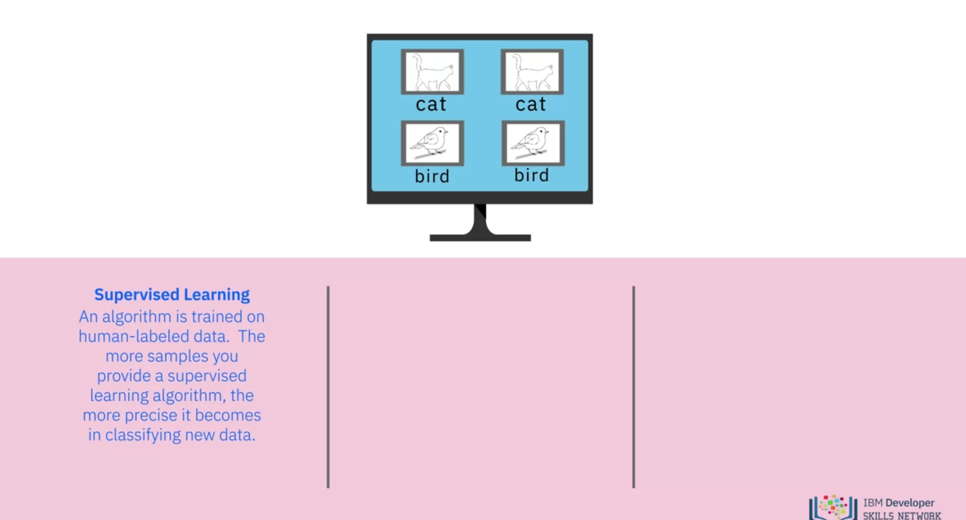

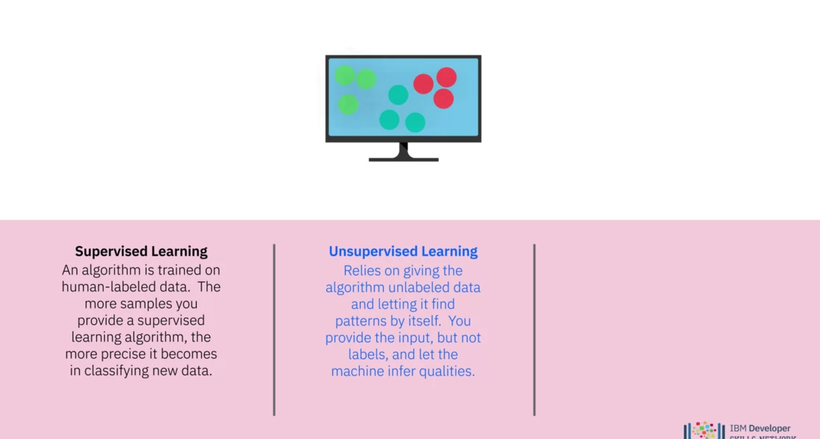

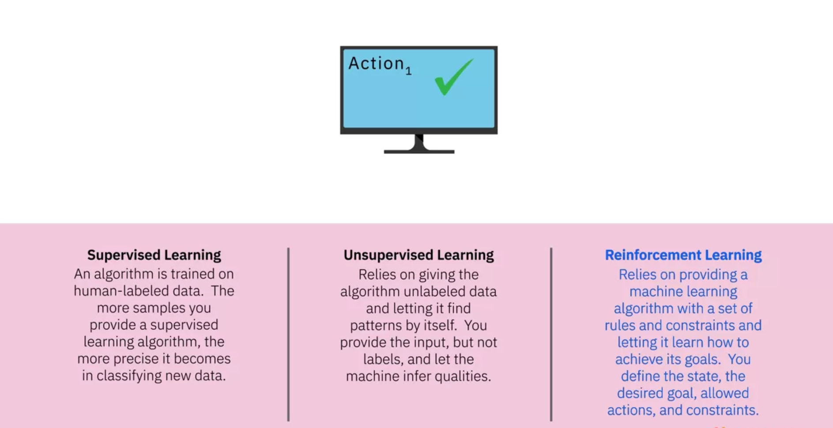

Reinforcement learning relies on providing data and constraints and letting the model learn how to achieve desired results by trying different combinations of allowed actions, giving a reward or punishment depending on whether the decision was a good one. Reinforcement learning algorithms can teach a machine to play chess or even navigate an obstacle course.